**Devops Boot Camp Assignment**

**Jenkins URL :-** [**http://192.168.1.160:8080/**](http://192.168.1.160:8080/)

**Job Link :-** [**http://192.168.1.160:8080/job/Deploy_Tomcat_Container_Ansible_Kubernetes/**](http://192.168.1.160:8080/job/Deploy_Tomcat_Container_Ansible_Kubernetes/)

**GitHub Repository**

[**https://github.com/ikramshahbaz/DevopsBootCamp-war-01-.git**](https://github.com/ikramshahbaz/DevopsBootCamp-war-01-.git)

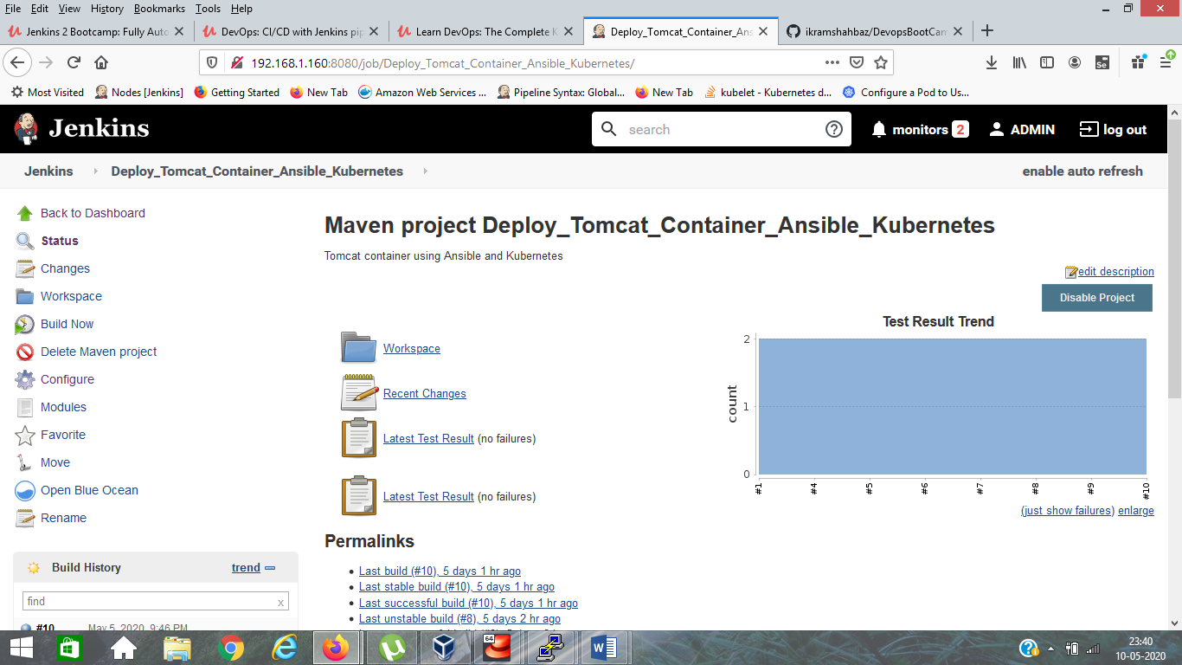

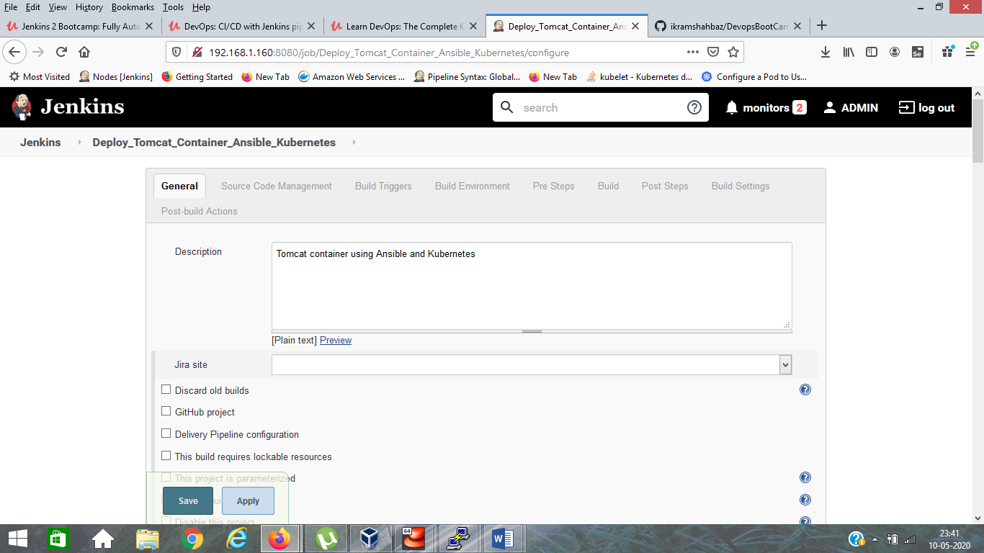

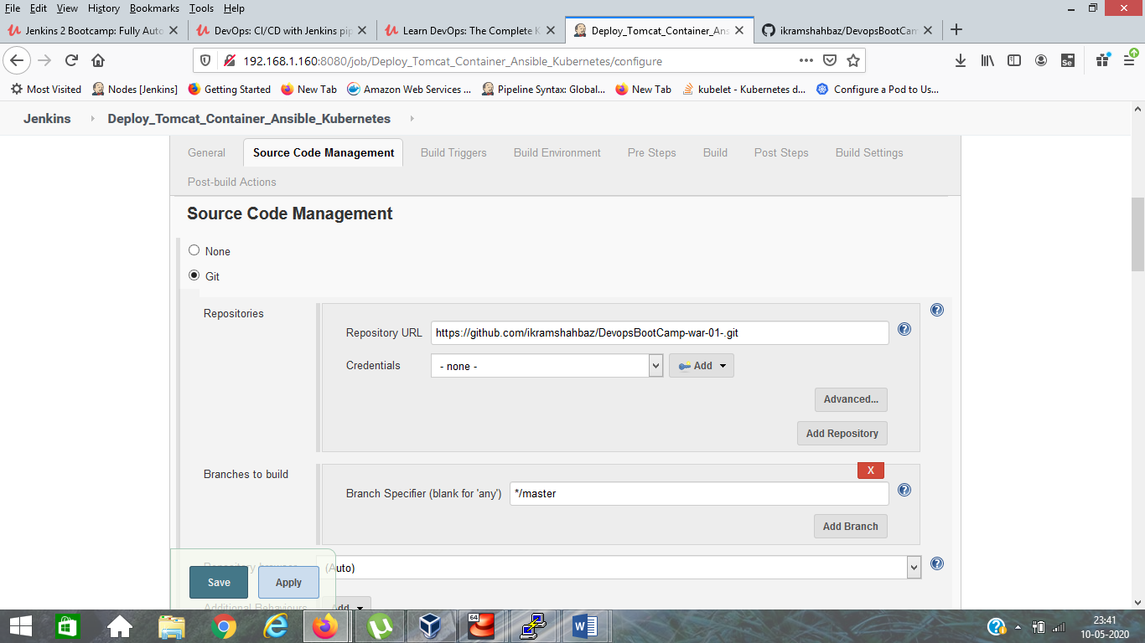

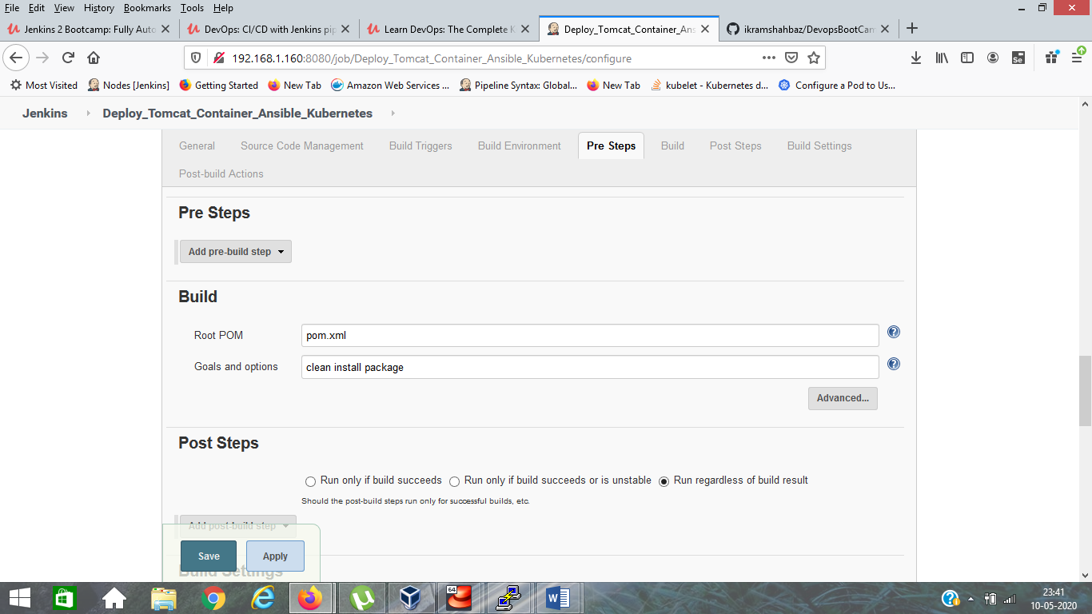

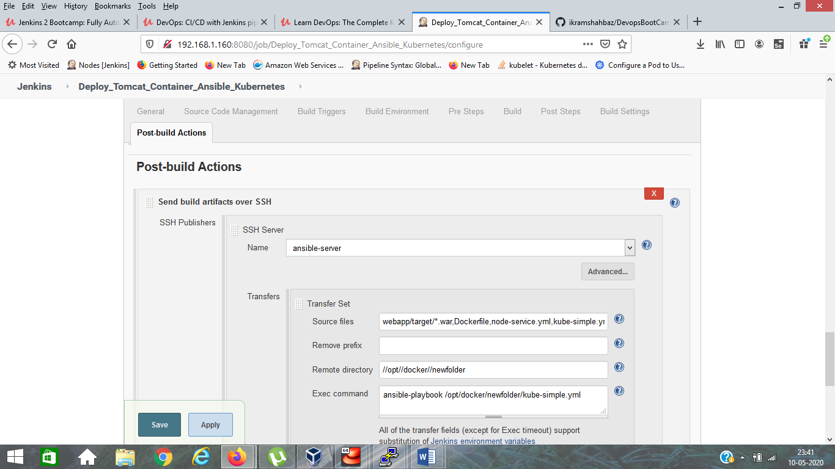

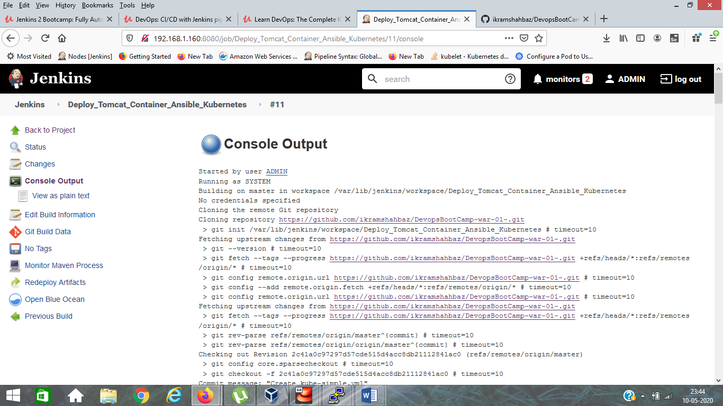

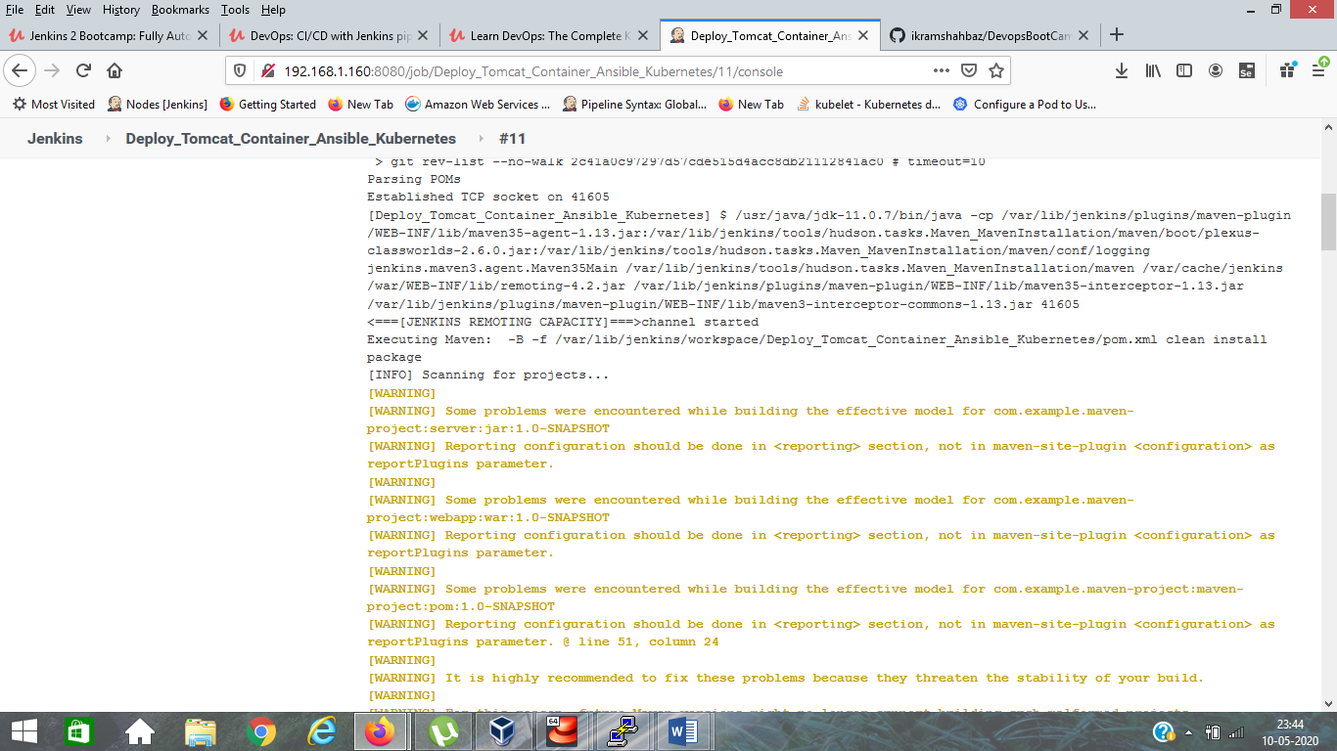

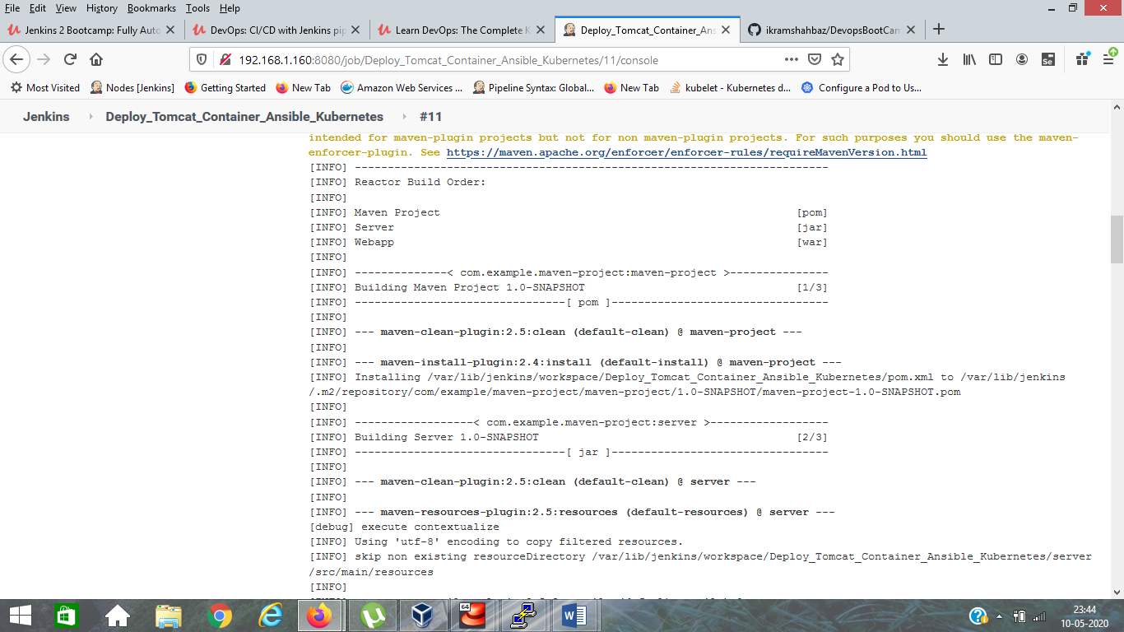

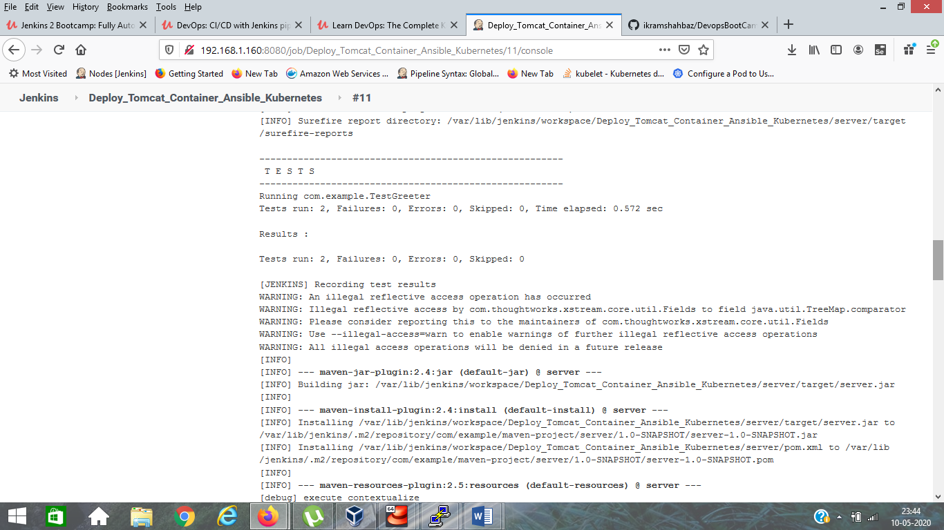

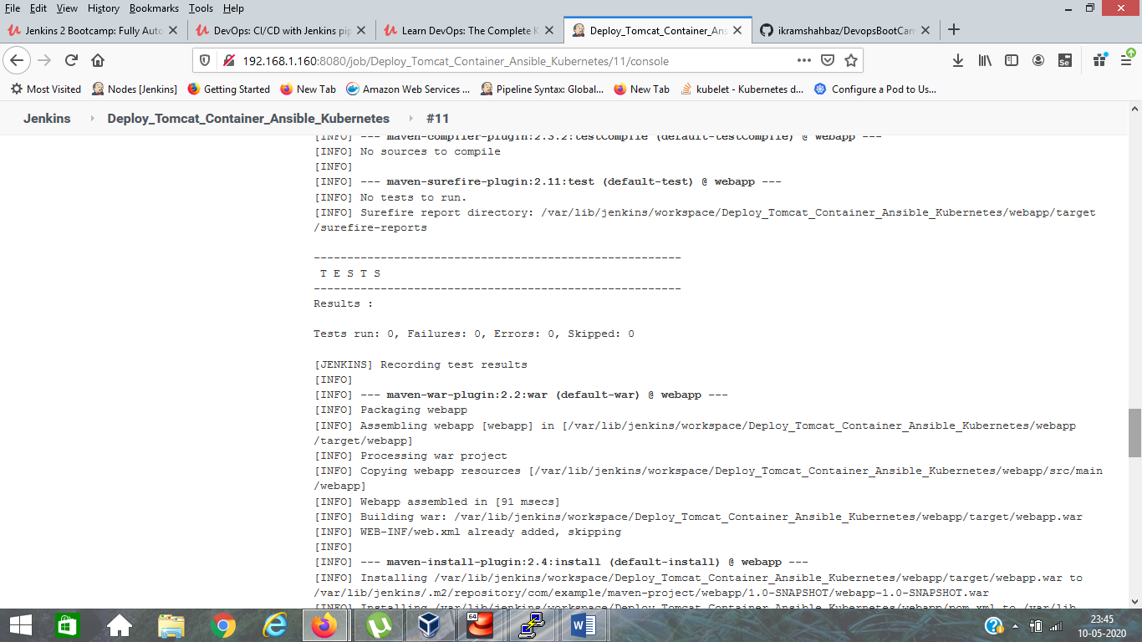

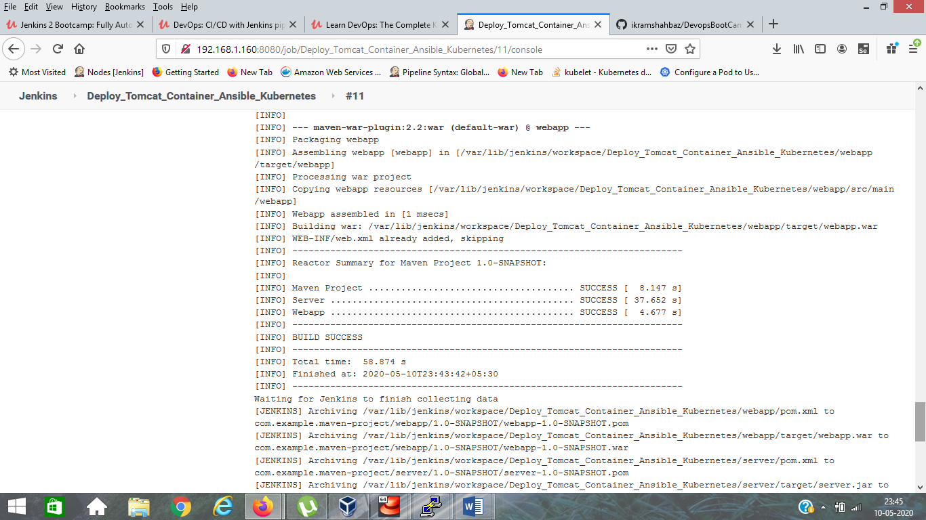

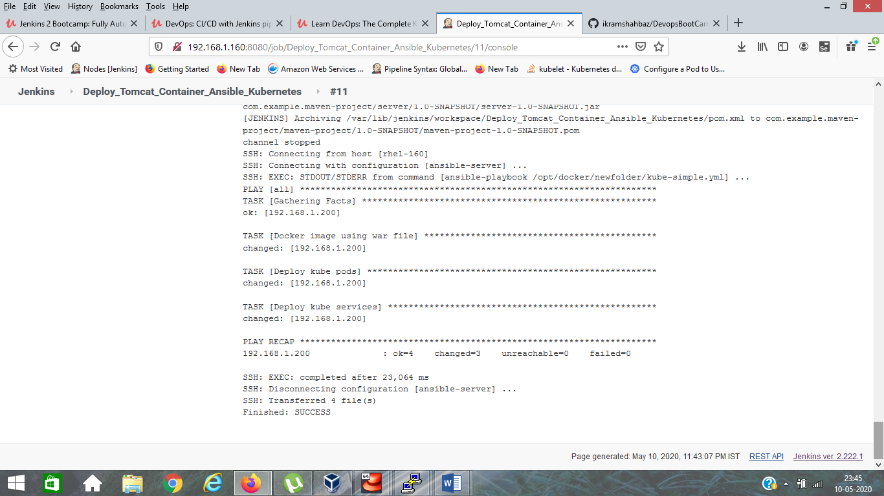

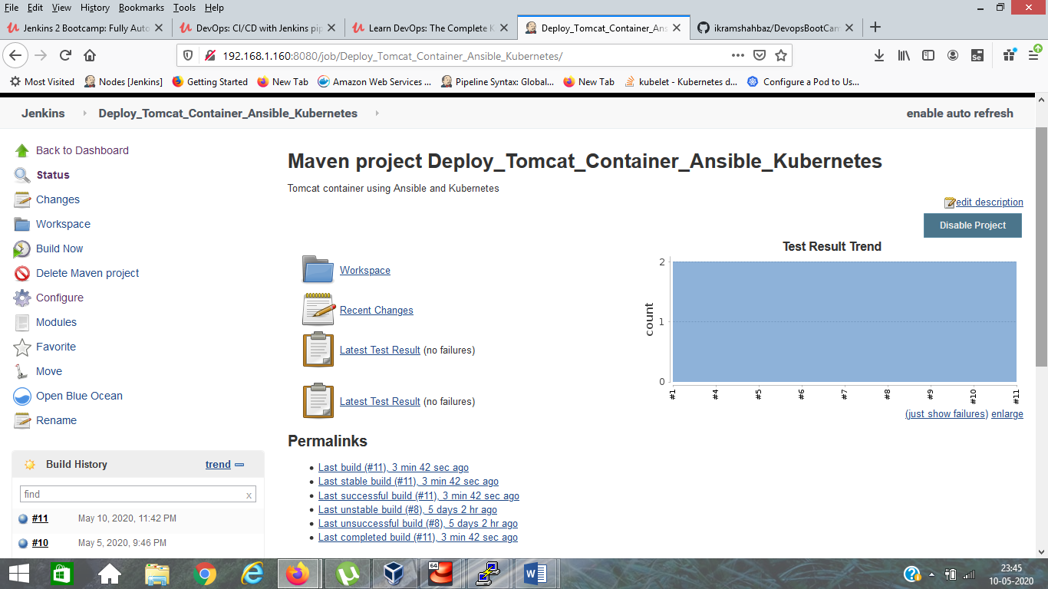

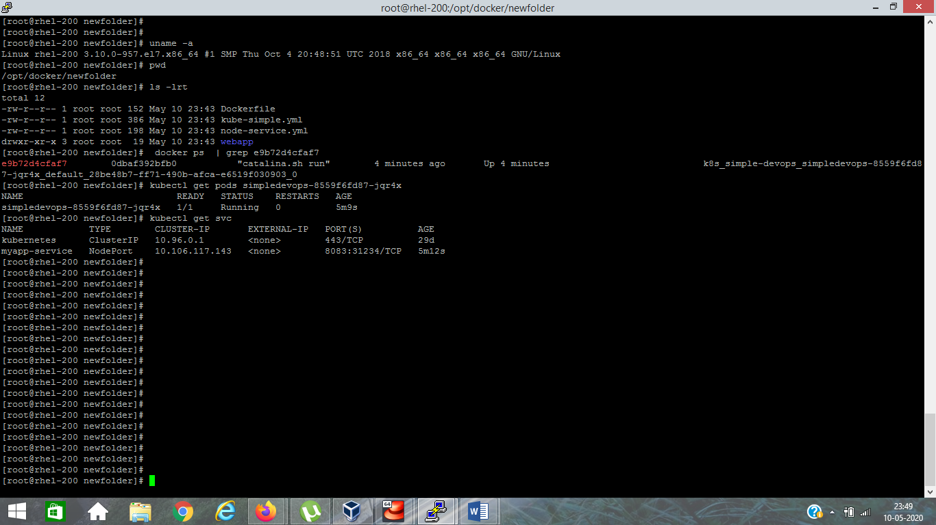

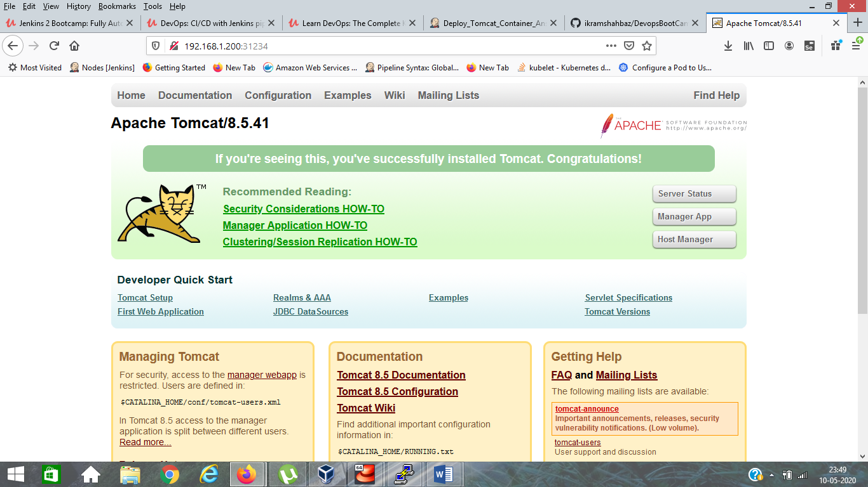

Application Link :- <http://192.168.1.200:31234/webapp/>

